Experiment 4
Description: Create a simple cloud software application for Car Booking Reservation System using any Cloud Service Provider to demonstrate SaaS.
Aim
To implement and deploy a car booking reservation system using a SaaS model.
Procedure
- Create booking modules: Car List, Availability Check, Booking Form.
- Store data in cloud database.
- Deploy application as a service.
- Test booking workflow.
Output:
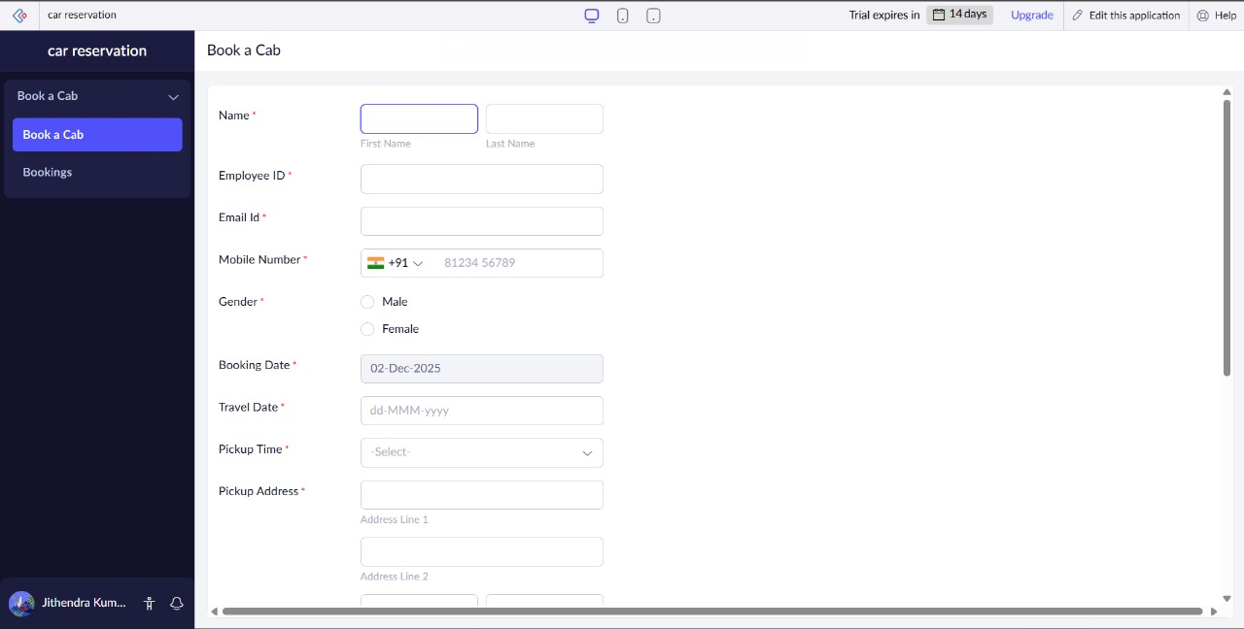
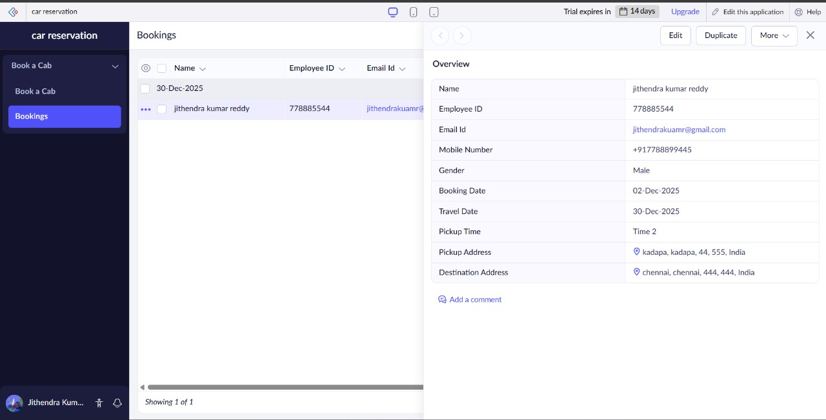
Result
Car booking system was successfully deployed and made accessible as SaaS.

